**Building A High**

**Performance Team**

**- A Process for Building and Managing Teams -**

**Introduction**

The survey is based on the following diagram which shows the eight issues which contribute to the creation of a high performing team.

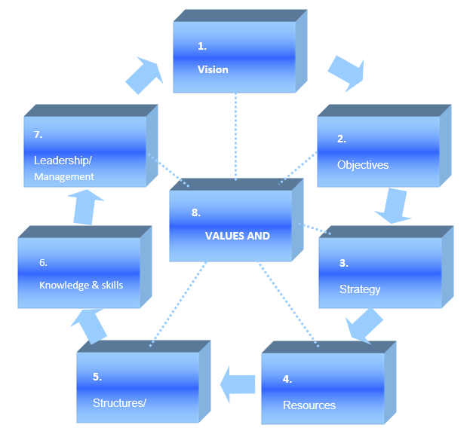

A brief explanation of each issue is provided below.

**The Eight Issues**

**Vision** is a vital step in team building. Vision asks the question ‘what is the preferred future we are trying to create as a team?’

**Objectives** put measures of success to the team’s vision and ask the question ‘how will we know if we are to succeed as a team?’

**Strategy** is about the ‘how’ of achieving the objectives. It asks the question ‘by what means will we as a team achieve the objectives?’

**Resources** include finance, people, technology, premises and products. The question is ‘what resources will be required of us as a team to deliver the objectives and strategy?’

**Structures / Systems** involve using resources in the most efficient way and measuring their performance. What organizational structure, what technical and information systems and processes will be required by the team and deployed by the team are the key issues.

**Knowledge & Skills** refers to the measurable knowledge, skills and know-how which will be required of team members to work effectively as a team in the team structure and to develop as team members.

**Leadership and Management** asks the question what impact does the leadership style and management skills of the team leader have on the team members, and do team members respond well to its leader?

**Culture and Values** refers to the core values and commonly held benefits which bind team members together and result in behavioural norms that help the team function as one unit.

**Building High Performance Teams Survey**

**Answer each statement with *ONE tick only* in one of the three boxes**

⎕= Yes ⎕= In Part ⎕= No

Commence each statement with the words **THE TEAM……**

|  |  |  |  |
| --- | --- | --- | --- |
|  | **Y** | **P** | **N** |
| **CULTURE AND VALUES** |  |  |  |
| 1. Understands the behaviours needed to support the culture and values required; talks openly about them. |  |  |  |
| 1. Has bought into the culture and values required and is committed to them. |  |  |  |
| 1. Exhibits behaviours that support the required culture and values. |  |  |  |
| 1. Actively uses the culture and values in decision-making and conflict resolution. |  |  |  |
| 1. Appropriately challenges those not exhibiting the required culture and values |  |  |  |
| **VISION** |  |  |  |
| 1. Is clear about the overall vision and direction for the business. Has consistent views about the way forward to support the vision. |  |  |  |
| 1. Can relate this vision to their individual jobs; is optimistic about what they can achieve. |  |  |  |
| 1. Is excited about the vision which they find attractive, elevating, and inspiring. |  |  |  |
| 1. Is solution orientated when overcoming obstacles to achieving the vision. |  |  |  |
| 1. Understands the 'win in it for them' in the vision. |  |  |  |
| **OBJECTIVES** |  |  |  |
| 1. Understand the team's purpose and overall Objectives. |  |  |  |
| 1. Can relate the team's objectives to the overall goals of the organisation. |  |  |  |
| 1. Believes the objectives are achievable (if stretching). |  |  |  |
| 1. Is committed to achievement of both hard and soft objectives/performance measures. |  |  |  |
| 1. Actively seeks to contribute to creating future team objectives. |  |  |  |
| **STRATEGY** |  |  |  |
| 1. Can differentiate between tactics and strategy. |  |  |  |
| 1. Understands the strategy for their part of the business. |  |  |  |
| 1. Is able to look at the big picture as well as the detail when making decisions. |  |  |  |
| 1. Can think strategically when solving problems. |  |  |  |
| 1. Is excited about the organisation's evolving strategy. |  |  |  |
| **RESOURCES** |  |  |  |
| 1. Is clear about and supportive of planning processes and procedures. |  |  |  |
| 1. Is clear about individual roles and responsibilities within the team. |  |  |  |
| 1. Understands the financial impact of one resource on another. |  |  |  |
| 1. Knows how to leverage resources to best effect. |  |  |  |
| 1. Can work well in subgroups. |  |  |  |
| **STRUCTURES AND SYSTEMS** |  |  |  |
| 1. Understands their fit into the organisation as a whole, who their customers are. |  |  |  |
| 1. Functions well within its own team structure. |  |  |  |
| 1. Relates and links well to other teams and functions. |  |  |  |
| 1. Uses internal systems to optimum effect. |  |  |  |
| 1. Can respond effectively to data and information it receives. |  |  |  |
| **KNOWLEDGE & SKILLS** |  |  |  |
| 1. Understands the knowledge and skills requirements of each job within the team. |  |  |  |
| 1. Has behavioural performance measures to measure use of skills. |  |  |  |
| 1. Can employ the softer/interpersonal skills to build positive long-term relationships. |  |  |  |
| 1. Is committed to ongoing learning and development. |  |  |  |
| 1. Actively seeks to grow its skills and capabilities for future effectiveness. |  |  |  |
| **LEADERSHIP AND MANAGEMENT** |  |  |  |
| 1. Responds positively to the demands placed on it. |  |  |  |
| 1. Accepts the changes required of it. |  |  |  |
| 1. Shows a favourable response to the management style used with it. |  |  |  |
| 1. Is motivated by the communications it receives and how it receives them. |  |  |  |
| 1. Has a positive relationship with its leader/manager and is not afraid to challenge/manage upwards in an appropriate way. |  |  |  |
| **SUB TOTALS (Total the number of ‘ticks’ in each column)** |  |  |  |

**SCORING YOUR SURVEY**

For each **Y** box score 2 points Total ‘Y’ Score =

For each **P** box score 1 point Total ‘P’ Score =

For each **N** box score o points Total ‘N’ Score =

**Interpreting Your Score**

80 Points - Are you sure?!?

60-80 Points - A high performing team with development needs

40-60 Points - A good team in need of improvement

20-40 Points - Just about a team

0-20 Points - Barely a collection of individuals!

**Diagnosing Your Team Building Needs**

|  |  |  |
| --- | --- | --- |
| **AREA OF WEAKNESS** | **REASON FOR WEAKNESS** | **IDEAS TO STRENGTHEN** |
|  |  |  |